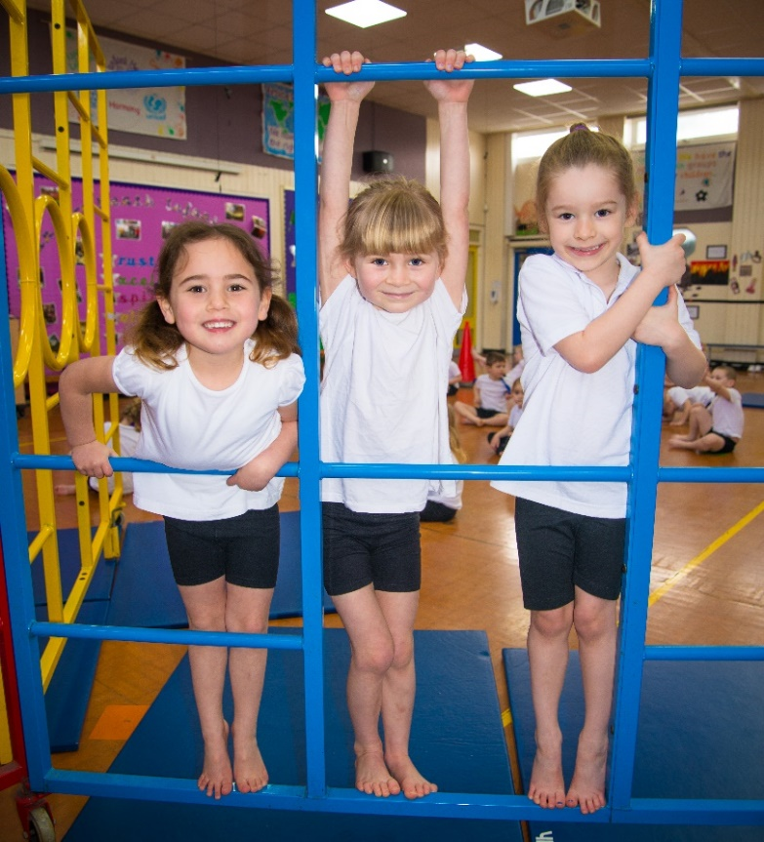
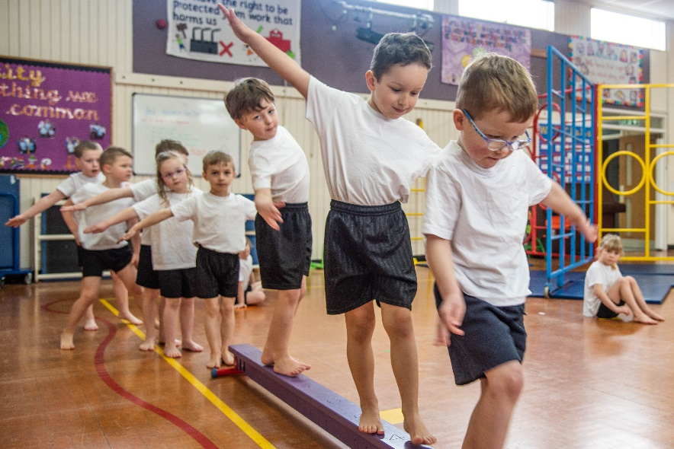
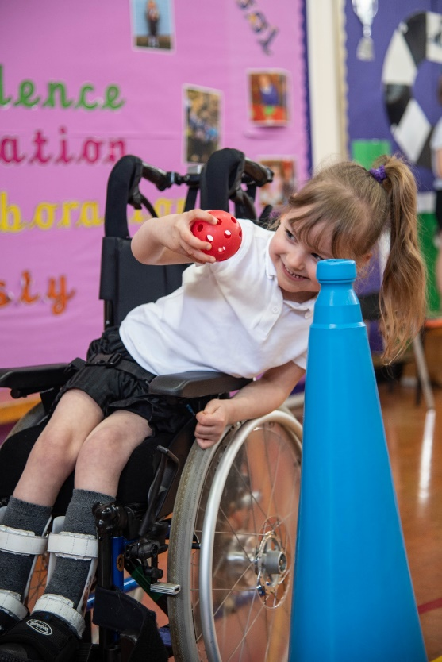
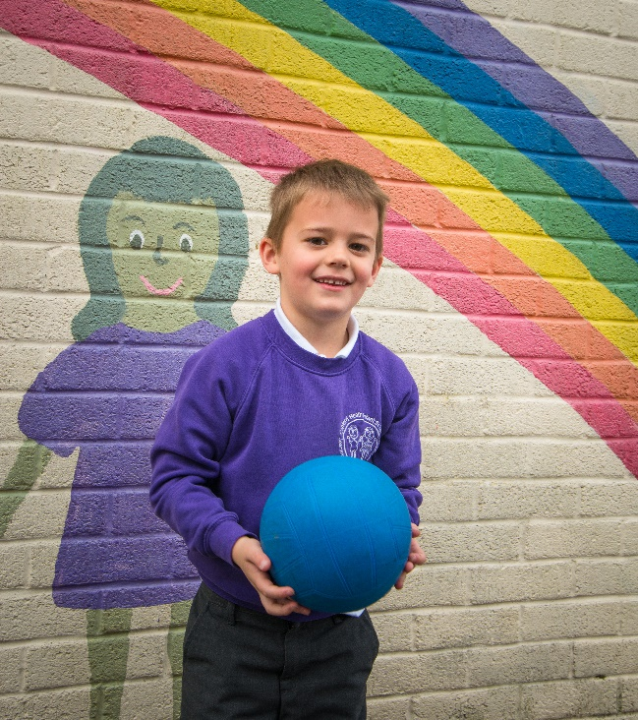
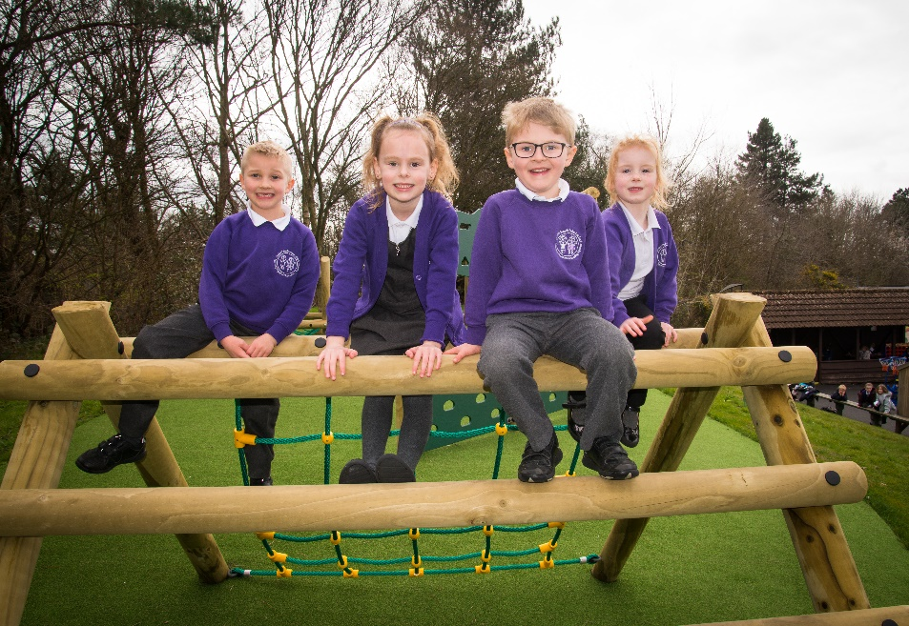
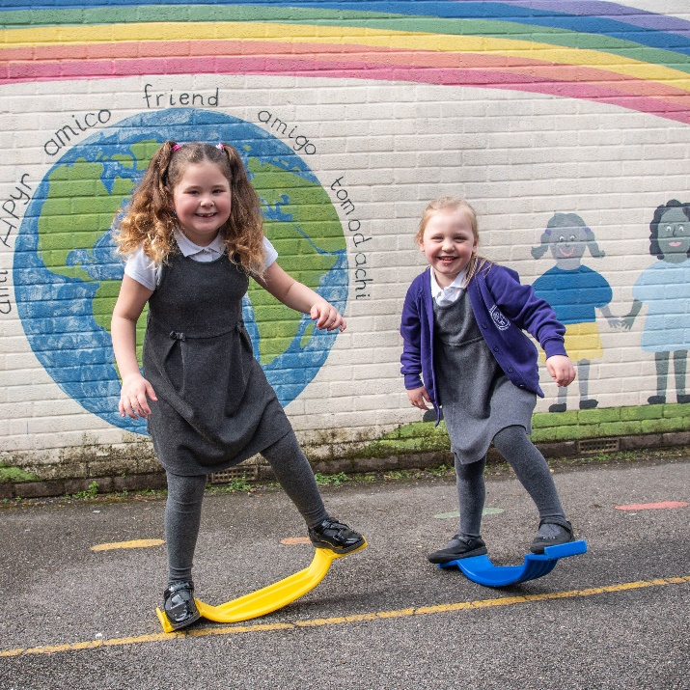


CANFORD HEATH INFANT SCHOOL

PE AND SPORTS PREMIUM IMPACT REPORT FOR THE 2023-2024 ACADEMIC YEAR
Details with regard to funding

Total amount allocated for 2023/24 | £18,390
Total spent and reported on by 31st July 2024 | £20,996
Total carried over into 2023/24 | £2,606
Swimming Data

Meeting national curriculum requirements for swimming and water safety.  N.B. Complete this section to your best ability. For example, you might have practised safe self-rescue techniques on dry land which you can then transfer to the pool when school swimming restarts.  Due to exceptional circumstances priority should be given to ensuring that pupils can perform safe self-rescue even if they do not fully meet the first two requirements of the NC programme of study | N/A – swimming takes place at our partner junior school.
What percentage of your current Year 6 cohort swim competently, confidently and proficiently over a distance of at least 25 metres?  N.B. Even though your pupils may swim in another year please report on their attainment on leaving primary school at the end of the summer term 2020.  Please see note above | N/A  %
What percentage of your current Year 6 cohort use a range of strokes effectively [for example, front crawl, backstroke and breaststroke]?  Please see note above | N/A  %
What percentage of your current Year 6 cohort perform safe self-rescue in different water-based situations? | N/A %
Schools can choose to use the Primary PE and sport premium to provide additional provision for swimming but this must be for activity over and above the national curriculum requirements. Have you used it in this way? | Yes / No

Action Plan and Budget Tracking

Key indicator 1: The engagement of all pupils in regular physical activity – Chief Medical Officers guidelines recommend that primary school pupils undertake at least 30 minutes of physical activity a day in school |  |  |  | Percentage of total allocation:
 |  |  |  | 57.44% £12059.70
Intent | Implementation |  | Impact | Sustainability and suggested next steps
•Engagement of all pupils in regular physical activity – kick-starting healthy active lifestyles | • Purchased PE equipment to enhance scheme of work, including EYFS curriculum.  • Annual safety inspection of equipment/repairs on PE equipment  (Universal Services).  • All year groups participated in ‘Mile a Day’ (EYFS once or twice a week to build up).  • Provide a play leader to encourage active play and supervise the play equipment.  • Purchased additional equipment to encourage active play. | £3,002.02  £239.78  £0.00  £2,121.00  £6696.90 | • With the recently purchased PE scheme, new equipment ensured we continued to enhance their physical activity and improve their fine/gross motor skills. There is now progression from KS1 to KS2.  • Ensured equipment installed is safe to use and recommendations are actioned for safe, PE lessons.  • Enhanced physical fitness and engagement of their brains and increased level of activity in school time 50%.  • Encouraged to take part in prescribed and purposeful active playtimes with a clear focus.  • Enhanced physical fitness and engagement which has encouraged and promoted physical activity. | •Equipment bought to match adaptions in the PE scheme, inc scooters/bikes/fine & gross motor skills objects for EYFS. NS-core strength equipment (balancing) and gross motor (planks).  •Play equipment installed is safe to use regularly and will have a longer life span. NS-regular checks.  •Promoted well-being and positive outlook on physical activity ensuring long term effects. NS- celebrate in assembly.  •Children taught how to use the equipment and play active games efficiently. NS-addition play leader in Year 2.  •Range of equipment for ALL children. NS-continued physical activity on playgrounds.
Key indicator 2: The profile of PESSPA being raised across the school as a tool for whole school improvement |  |  |  | Percentage of total allocation:
 |  |  |  | 32.98% £6923.80
Intent | Implementation |  | Impact | Sustainability and suggested next steps
•Raise the profile of PE and Sport across the school for whole school improvement (relating to the School Improvement Plan for developing growth mindset and provisions for the disadvantaged children). | •‘Premier Sports’ -staff CPD took place in the afternoon during curriculum time and ran a lunchtime club for PP/SEND chn.  •Purchased sport books/sporting heroes for library sports section.  •Expand Forest School on site.  •Sports transition afternoon arranged and led by PE lead.  •Purchased resources for SEND (to enable ALL pupils to participate in all aspects of PE) and storage (for sustainability). | £3468  £46.02  £2359.70  £0.00  £872.72  £177.32 | •Staff CPD has improved quality of teaching.  •Aided in the PE curriculum and broadened children’s views on a range of sporting heroes. This worked alongside the whole school approach of learning about significant people.  •Promoted the holistic development of all involved, fostering resilient, confident, independent and creative learners.  •100% pupils went to CHJS from CHIS to attend transition afternoon.  •SEND children participated in all PE lessons, lessons adapted and equipment bought to enable 100% participation. Ensured longevity of the equipment. | •NS-Club lead to send out parent questionnaire to find out which clubs are wanted.  •Linked reading with sport and significant people. NS-continue to introduce higher quality texts.  •Continue with Forest School. NS:more qualified teachers to run extra-curricular clubs after school and train MDSA to use it at lunchtime.  •Continue next year to ensure effective transitions. NS-create smaller groups for well-being.  •Ongoing development to adapt with changes to our SEND children and ensuring all chn participate in PE despite their needs. NS-PE lead to liaise with appropriate outside agencies ie physiotherapists.

Key indicator 3: Increased confidence, knowledge and skills of all staff in teaching PE and sport |  |  |  | Percentage of total allocation:
 |  |  |  | 0%
Intent | Implementation |  | Impact | Sustainability and suggested next steps
•Increase confidence, knowledge and skills of all staff in teaching PE and sport. | •Teachers and HLTA- CPD took place with Premier Sports (Outdoor PE lessons once a term per year group).  •Maintain programme of obs by PE lead and team-teaching of lessons to assess CPD needs. PE lead monitored and coached in all year groups for support and to ensure continuity and progression. | - See  combined amount for Premier Sports above.  £0.00 | • HLTAs/Teachers felt more confident and Premier Sports staff did more team teaching where the staff worked together to run and do the sport activities alongside each other.  •PE lead/observed PE lessons, ensured skills and techniques were being put into practise and that progression and continuity was evident through using the schemes of work. Provided feedback. | • NS-Premier Sports will team teach and will change to gymnastics and dance.  •NS-PE scheme to be adapted further…PE assistant lead to oversee.
Key indicator 4: Broader experience of a range of sports and activities offered to all pupils |  |  |  | Percentage of total allocation:
 |  |  |  | 3.43% £720
Intent | Implementation |  | Impact | Sustainability and suggested next steps
Additional achievements:  •Provide broader experiences in a range of sports and activities to all pupils. | •‘Premier Sports’ PP active lunchtime club (archery/handball/fundamental skills/ball skills).  •A range of after school clubs are offered Handball, Gymnastics, Football, Cheerleading, Strictly Stage, Tennis and Archery.  •Outdoor Education Visit- active school trips that encourage physical activity. | £0.00  (Amount is calculated within Premier Sports in section 2)  Funded by own companies but organised through school.  £720 | •Encouraged and inspired PP children to engage in physical activity. Seen an increase in their confidence, self-esteem and attitude in PE and Sport.  •Broadened and encouraged participation in varied sports and open them up to different sports. School run clubs to subitise to encourage children to uptake the clubs.  •Broadened experiences, increased engagement and participation in a range of physical activities, where there was purposeful and active interactions with peers. | • Premier club to continue with staff CPD and will continue with lunchtime clubs with a focus on pp children.  •Parents were asked at the beginning of the year as to which clubs were requested. NS-teachers will run after school clubs.  •Enabled all children in including SEN to access outdoor education. NS-to find an even more active OAA centre.

Key indicator 5: Increased participation in competitive sport |  |  |  | Percentage of total allocation:
 |  |  |  | 6.15% £1292.50
Intent | Implementation |  | Impact | Sustainability and suggested next steps
•Increase participation in competitive sport. | •Purchase sports day resources.  •Take part in Poole School Games event.  •Bikeability sessions for EYFS. | £1292.50  £0.00  Minibus cost  £0.00 | •Strengthened home-school links allowing parents to share their child’s achievements (celebrated through medals, certificates etc). Activities tailored to the age and ability of the children- every child was made to feel successful.  •Children exposed to new sports and skills in order to develop an interest in these sports/activities.  •Bikeability enabled EYFS to improve their fine/gross motor skills. | •To continue with this annual event. NS-to look at evaluation sheets and put in place refreshments.  •To continue to be a part of Poole School Games. NS-ensure the opportunities are taken up and organised with sufficient time.  •To continue to be a part of Bikeability to ensure all EYFS children learn to ride a bike.

Signed off by
Head Teacher: | L.Palmer
Date: | 14.07.24
PE Subject Leader: | J.Taylor
Date: | 14.07.24
Trustee: | K.Carter
Date: | 14.07.24

