

Registered Address: Canford Heath Infant School, Learoyd Road, Poole, BH17 8PJ
Telephone: 01202 380015 Fax: 01202 257408 Email: contact@teachpoole.com
Company Number: 09484306
@TEACH_Trust

Dear Parent/Carers
You are receiving this paperwork because your child is taking part in the TEACH Trust summer concert on Wednesday 8th July at the Lighthouse.
Please find attached details on the following-
- Rehearsal breakdown
- Evening concert details
- Morning drop off plan and map

Please be aware that there will be no Canford Heath Infant choir in the morning on the day.
On the morning on the concert, I will have a large number of staff all positioned at the front, rear and opposite the Lighthouse. I have made separate drop off points for each school to try and stop causing any traffic issues. Please can I ask that you pull in, drop off your children and drive on. The staff will help your child to their registration point. If you want to walk your child in, please can I ask that you park away from the Lighthouse and walk in.
INFANTS – all infant children are to be dropped at the front door of the Lighthouse
HAYMOOR – all children to be dropped in the coach car park opposite the Lighthouse
CANFORD HEATH JUNIOR – all children to be dropped at the back entrance to the Lighthouse
If you have infant and junior children, please drop them all at the infant drop off point.
Please feel free to contact me if you have any further enquiries on music@teachpoole.com
Yours sincerely
R Turner
Mrs Rebecca Turner
Community and music performance director

FINAL DETAILS FOR THE TEACH TRUST SUMMER CONCERT
WEDNESDAY 8th JULY 2026 - AT THE LIGHTHOUSE, POOLE

DAYTIME REHEARSAL
 | MORNING | Children are to be dropped off at the Lighthouse between 8.15am and 9.00am – please see attached plan  We have tried to make things as easy as possible to avoid traffic issues. Please stick to our suggestions if possible.  INFANTS – all infant children are to be dropped at the front door of the Lighthouse  HAYMOOR – all children to be dropped in the coach car park opposite the Lighthouse  CANFORD HEATH JUNIOR – all children to be dropped at the back entrance to the Lighthouse  If you have children at both the infant and junior schools, please drop them all at the infant entrance.
 | INFANT RETURN | The infant children will be returning to school on a coach so that they are back at school for a normal lunchtime. They will have a normal afternoon at school and a normal end of day collection.
 | JUNIOR RETURN | We have four coaches that will be dropping the children back to school at different points throughout the afternoon. All children will be back at school for a normal end of day collection.
 | FOOD | Infant children will be back at school for a normal lunchtime.  The junior children will need a packed lunch. If your child normally has a free meal at school, a packed lunch will be provided.  Please cancel all booked hot meals for junior school children.  There will be no food heating facilities.  Healthy snacks from home will be required during the day.
 | DRINK | The children will need at least two bottles of water for the day.  No fizzy drinks please
 | ENTERTAINMENT | Sorry, but due to school policies, NO ELECTRONIC DEVICES (phone, i-pads etc …) are allowed on the trip.  Any children’s phones will be collected in the morning and then handed back to the children at home time.  Please bring other forms of entertainment, e.g. cards, books, colouring books, top trumps.
 | MEDICATION | The school first aider will ensure that all medication from school is given to the lead first aider.  In line with our school medical policy – if your child requires any further medication that is not held in school please go to the offices and complete a medical form PRIOR to the event.
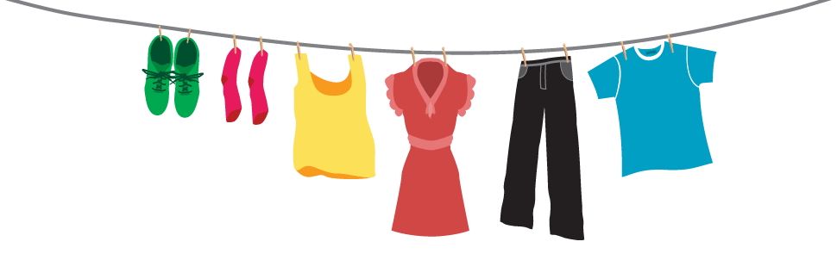 | DAY UNIFORM | Normal school uniform is to be worn for the rehearsal - summer dresses are allowed for the day
Please phone the school for any emergency communications during the day.

EVENING CONCERT
 | TIMING  WHERE TO TAKE YOUR CHILD WHEN THEY ARRIVE | Children need to be back at the Lighthouse by 5.45pm prompt please  INFANT  On arrival, all infant children need to go around to the right-hand side of the theatre and enter through the side stage door, this will be clearly signposted.  JUNIOR  On arrival, all junior children should go straight to the main theatre door and up to the first floor, where staff will register them inside the theatre. They will not be allowed to exit again.  Parents please wait in the foyers, away from the door. You will be allowed in the main theatre at 6.15pm  The concert will start at 6.30pm and should finish around 8.00pm
 | PARKING | Please allow time to find parking before the concert, it will be busy
 | FOOD/  ENTERTAINMENT | No drinks will be allowed to be taken onto the stage with the children in the evening.  No entertainment, food or drink required.  The café and bar will be open from 4.30pm
 | UNIFORM | Smart school uniform please  No summer dresses allowed  As per school policy, no trainers allowed  Hair tied back  Juniors – blouse or shirt / tie (no polo shirts)  Shorts / trousers / skirts / pinafores  Smart shoes, no trainers  Infants – normal  No summer dresses  No jumpers or cardigans allowed due to the temperature
 | DRESSING UP OUTFITS | All junior school boys’ choir = Bugsy Malone outfit  All infant school choir children = an animal  Dancers have been contacted separately.  Please send into school in a named bag as soon as possible.  Everyone else is in winter concert uniform. No summer dresses.
 | COLLECTION AFTER THE EVENT | Please see the map below for the collection points. It will also be printed on the rear of the program and announced on the night several times.
 | Video | A professional video will be taken of the evening and available to purchase after the event.
Programmes will be on sale at the start of the event at £3 each

We will be holding a chocolate raffle at the start of the event at £2 a ticket.

Cash, if possible, but card will be available

All proceeds go to purchasing new instruments for the music department
Overall lead is Mrs Turner. Each school has a lead first aider

COLLECTION POINTS FOR AFTER THE CONCERT

STAGE
ALL INFANT children will exit from the rear stage door. Please go out of the main doors and walk around to the right of the theatre to the collection point. | ALL HJS children will exit from the right hand of stage exit door into car park. Please go out of the main doors and walk around to the left of the theatre to the collection point.
Children in the cheerleaders, brass band and orchestra can be collected from the LEFT steps of the stage once they have collected their belongings from their dressing room. | Boys choir will return to their dressing room and collect their clothes before being collected from the RIGHT hand steps of the stage inside the main theatre.

MIDDLE FLOOR

Concert hall door
CHJS
YEAR 5

CHJS
YEAR 4
CHJS
YEAR 6
Bar
GROUND FLOOR
Main ticket desk
CHJS
YEAR 3
L
I
F
T
S
Cafe
Main entrance and exit for all

