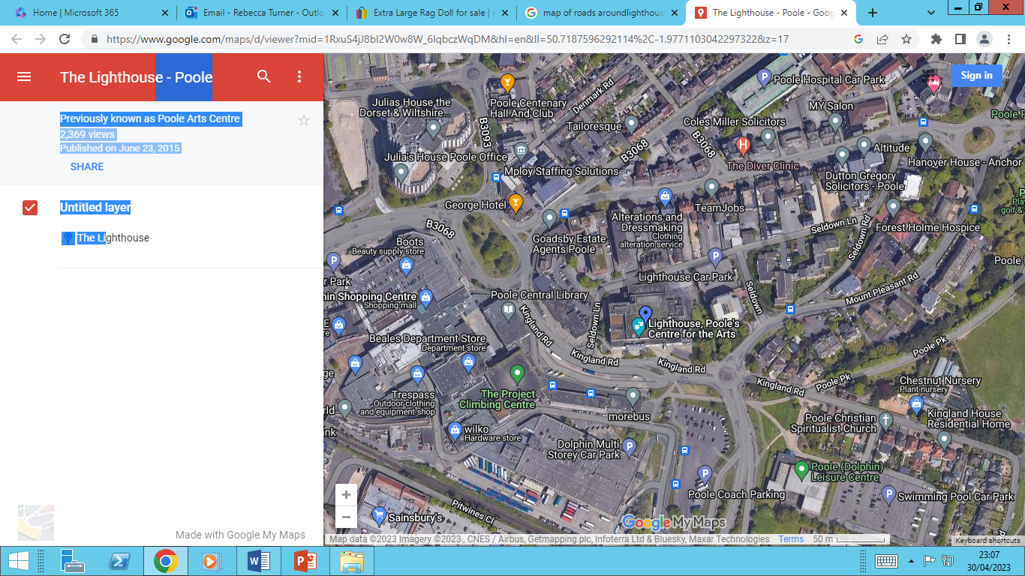
L
TEACH TRUST Concert pupil drop off map
Wednesday 8th July
Between 8.15am and 9.00am
CHJS drop off
Stage door, at the back of Lighthouse

CHJS drop off
Stage door, at the back of Lighthouse

CHJS drop off
Stage door, at the back of Lighthouse

INFANT drop off Drive into the front of Lighthouse
HJS drop off point
Coach car pack, opposite Lighthouse

