

Canford Heath Infant School

Child Protection & Safeguarding 2026-2027




Deputy Designated
Safeguarding Lead:
Kate Carter
Deputy Designated Safeguarding Lead:
Laurin Palmer

Designated Safeguarding Lead:
Julie Taylor
Pastoral Care Worker/ Deputy Designated Safeguarding Lead:
Rachael Lippitt

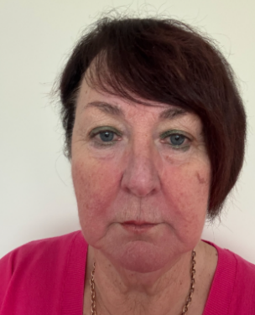

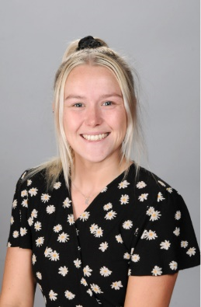


Designated Safeguarding Trustee:
Julie Jeans
Designated
Anti-bullying Champion:
Tess White
Home Academy Liaison Officer:
Lesley Specterman
Designated
E-Safety Champion:
Rachal Woodman

Prevent Lead:
Julie Taylor

Site Security Lead:
Simon Caveney

BCP Local Authority Designated Officer (LADO)
Allyson Donovan, Hayley Cowmeadow, Tina Cooper
Telephone: 01202 817 600
Email: LADO@bcpcouncil.gov.uk


