Climate Action Plan
Canford Heath Infant School

January 2026- January 2027

Organisational Strategic Objective:
To work towards carbon neutrality and embed sustainable practices.

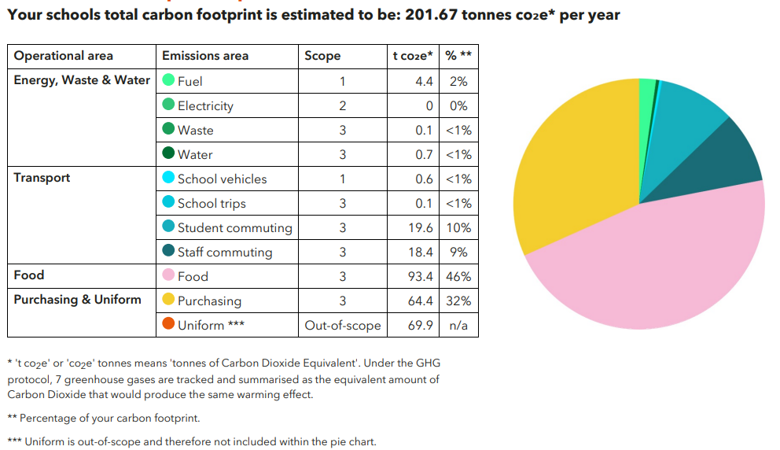

IMPLEMENTATION AND LAUNCH
CRITICAL SUCCESS FACTORS | TIMESCALE | KPIs | RACI INDEX | IMPLEMENTATION FACTORS | TRACKER
1.1 Sign up to the Let’s Go Zero campaign. | Dec 2025 | Written confirmation that all schools have signed up |  | 1.By joining this campaign, we confirm a commitment to reduce our carbon impact.  2.Signing up also provides us with appropriate expertise and guidance. | Complete
  CEO | RA
  CFO | I
  TEM | I
  HT | I
  SL | I
  HOCS | I
  STAFF | I
  PARENTS | I
  EXPERTS | C
1.2 Calculate our current carbon footprint. | Feb 2026  Feb 2026 | Data collected and checked.  Accuracy checked.  Data submitted to CYC.  Written calculation received. |  | 1.Responsible people to record data on required usage/spending to be able to calculate carbon footprint.  2.Use Count Your Carbon for each school to create baseline, using acquired data. | Complete
  CEO | RA
  CFO | R
  TEM | R
  HT | R
  SL | I
  HOCS | R
  STAFF | I
  PARENTS | I
  EXPERTS | C
1.3 Put in place a positive communication strategy to share our net zero work. | May 2026  June – Dec 2026  Sept 2026  Sept 2026  Sept 2026 – ongoing monthly  Sept 2026 – ongoing  January 2027 | 1.CPD planned and delivered  2.Responsilities allocated.  3.Badge added to literature.  4.Introductory post followed by monthly updates.  5.Sustainability matters added to school websites and newsletters.  6.Invite LGZ to Primary Heads to share CAP work. |  | 1.Plan and deliver a suitable CPD program for all staff.  2.Allocate responsibilities to pupils, staff and Trustees to support carbon neutral changes/adjustments.  3.Add Let’s Go Zero Pledge Badge to literature and stationery.  4.Share schools’ involvement to become carbon neutral on Trust-wide social media.  5.Add sustainability plans, projects and successes to our school websites and share through wider communications.  6.Encourage other schools/MATs to sign up. | In progress
  CEO | A
  CFO | R
  TEM | C
  HT | R
  SL | R
  HOCS | R
  STAFF | R
  PARENTS | I
  EXPERTS | C
1.4 Set up a sustainability working group  Assemble a Sustainability Working Group featuring different stakeholders across the school to collaborate and effect change.  Ensure one person has oversight, taking the title of 'Sustainability Lead'. | Jan 2026  April – May 2026  June 2026  April 2026 onwards | 1.Key people identified, training received and Action Plan shared.  2.CAP Action Plan shared with Trustees.  3.Roles and requirements agreed.  4.Work of ECO groups is continued. |  | 1.Discuss Climate Action Plan (CAP) with Headteachers and central leadership team.  2.Discuss CAP with Trustees and agree Trustee accountability/interest to join the SWG.  3.Headteachers to take on role as sustainability lead for the school and identify a key staff member to assist; CEO for the Trust.  4.Continue work of schools’ ECO groups – ensure the pupils (and any interested parents) are consulted on CAP matters.  NOTES  Sustainability related content and developing skills through, Climate Fresk  CPD sessions from UCL to help embed sustainability in different subjects.  Teaching for sustainable futures | UCL Institute of Education | Complete
  CEO | A
  CFO | R
  TEM | R
  HT | R
  SL | R
  HOCS | R
  STAFF | R
  PARENTS | C
  EXPERTS | C

2. Decarbonisation and Energy Efficiency
Calculating and taking actions to reduce carbon emissions and becoming more energy efficient.
ENERGY – BUILDINGS AND RETROFIT
CRITICAL SUCCESS FACTORS | TIMESCALE | KPIs | RACI INDEX | IMPLEMENTATION FACTORS | TRACKER
2.1 Install smart meters where they are not already in place. | Feb – June 2026  Feb 2026  May 2026 for leaders  June 2026 for staff  Sept – Dec 2026  Sept 2026 | 1.Gas, electric water meters successfully installed.  2.Energy Sparks is signed up to.  3.Energy Sparks training carried out.  4.Energy Sparks is successfully integrated into the curriculum.  5.Energy Champions created. |  | 1.Contact energy and/or water supplier to get a smart meter installed.  2.Sign up to Energy Sparks (energy usage platform).  3.Carry out Energy Sparks training for staff.  4.Incorporate Energy Sparks into the curriculum.  5.Create Energy Champions in each class.  NOTES  Request to fit smart meters have been made. | In progress
  CEO | A
  CFO | R
  TEM | R
  HT | I
  SL | R
  HOCS | R
  STAFF | R
  PARENTS | I
  EXPERTS | C
2.2 Optimise our building management system (BMS) settings to ensure the heating and hot water systems have efficient timings and temperatures set. | March 2026  March 2026  August 2026  October 2026  October 2026  Ongoing  August 2026 | 1.Building temperatures reduced to 19 degrees.  2.Timings cut by 30m each morning and 30m each evening.  3.Heating effectiveness reviewed and ineffective equipment replaced.  4.Radiator valves checked for appropriate settings.  5. Old thermostats replaced.  6.TRVs installed.  7.Radiators bled. |  | 1.Reduce building temperature by one degree.  2.Reduce time heating is on by one hour per day.  3.Review effectiveness of heating equipment in each school – replacing where required.  4.Ensure radiator valves are set appropriately for each area.  5.Replace any thermostats that are five years or older.  6.Install TRVs where they do not exist.  7.Bleed radiators every summer.  8.Undertake annual comparisons of each seasons’ energy usage. | In progress
  CEO | A
  CFO | C
  TEM | R
  HT | C
  SL | C
  HOCS | I
  STAFF | I
  PARENTS
  EXPERTS | C
2.3 Investigate the potential and cost of solar panels. | October 2026  October 2026  November 2026  November 2026 | 1.Permission checked.  2.Roof checked for suitability by providers.  3.Solar providers and purchase possibilities researched.  4.Comparison undertaken. |  | 1.Investigate requirement for permission.  2.Contact solar providers to check the suitability of our roof spaces.  3.Contact solar providers to research the financial models available (direct purchase, lease, community energy) including visiting other schools.  4.Compare approaches from at least three different providers to ensure appropriate solutions.  NOTES  The Greater South East Net Zero Hub Regional Net Zero Hubs (government funded organisation) offers free desktop solar feasibility sessions for impartial advice. molly.gregory@gsenetzerohub.org.uk  Possible providers:  Solar for Schools  Eden Sustainable. | Not yet started
  CEO | I
  CFO | RA
  TEM | R
  HT | I
  SL | I
  HOCS | I
  STAFF | I
  PARENTS | I
  EXPERTS | C
ENERGY – BEHAVIOURAL CHANGE
CRITICAL SUCCESS FACTORS | TIMESCALE | KPIs | RACI INDEX | IMPLEMENTATION FACTORS | TRACKER
2.4 Adopt a power down strategy for electrical devices and appliances. | July 2026  October 2026  August 2026 | 1.Timer-controlled switches investigated and costed.  2.Timer-controlled switches installed and set.  3.Electrical equipment shut down over school holidays. |  | 1.Investigate use of timer-controlled switches for whiteboards, charger trollies, printers and photocopiers.  2.Implement power-down strategies across the schools.  3.Whiteboards, charger trollies, printers and copiers to be powered down during holidays. | Not yet started
  CEO | A
  CFO | R
  TEM | R
  HT | R
  SL | I
  HOCS | I
  STAFF | I
  PARENTS
  EXPERTS | C
2.5 Improve staff awareness of most energy - efficient ways to heat own workspaces/classrooms. | October 2026  October 2026  October 2026 onwards | 1.Each staff member has received clear training on heat management in their workspace.  2.TRV training has taken place with new TRVs.  3.Radiators are off when windows are open. |  | 1.Give staff clear instructions on how to manage heating in areas for which they are responsible.  2.Ensure all relevant teachers/staff know where thermostatic radiator valves (TRVs) are and how to control their classroom thermostat.  3.Ensure all staff turn radiators off before opening windows, where relevant. | Not yet started
  CEO | R
  CFO | R
  TEM | RA
  HT | R
  SL | R
  HOCS | I
  STAFF | R
  PARENTS
  EXPERTS | C
2.6 Use a dedicated platform to regularly monitor energy use. | October 2026  June 2026  December 2026  December 2026 | 1.Energy baseload assessed.  2.Energy Sparks signed up to.  3.Data analysed for whole school reduction and curriculum purposes.  4.Data used to cut energy spending and use. |  | 1.Assess energy baseload (how much energy we use continually).  2.Sign up to Energy Sparks (energy monitoring platform) to visualise and understand our energy usage.  3.Analyse data for emerging patterns in day-to-day energy consumption.  4.With detailed data on our energy usage, decide where and when is best to target energy savings.  NOTES  Storage heaters to be turned down to an appropriate temperature. | Not yet started
  CEO | A
  CFO | R
  TEM | I
  HT | R
  SL | R
  HOCS | R
  STAFF | R
  PARENTS | I
  EXPERTS | C

FOOD
CRITICAL SUCCESS FACTORS | TIMESCALE | KPIs | RACI INDEX | IMPLEMENTATION FACTORS | TRACKER
2.7 Arrange a menu consultation through an external organisation. | Sept 2026  Sept 2026 | 1.ProVeg consulted.  2.Food order on menu adjusted to have plant-based options first. |  | 1.Ask new food provider to liaise with ProVeg for consultation.  2.Consider where and how plant-based meals are displayed on menus to reduce bias against these options  NOTES  Placing the plant-based option as the default option can support with this – already an option with current provider. | In progress
  CEO | R
  CFO | A
  TEM | I
  HT | I
  SL | I
  HOCS | I
  STAFF | I
  PARENTS | I
  EXPERTS | C

PROCUREMENT
CRITICAL SUCCESS FACTORS | TIMESCALE | KPIs | RACI INDEX | IMPLEMENTATION FACTORS | TRACKER
2.8 Develop a Sustainable Procurement policy. | December 2026  December 2026  Ongoing  Ongoing  Sept 2026  Ongoing  Ongoing | 1.Successful sustainable procurement factors identified.  2.Policy written and shared.  3.Proportion of items purchased or donated second hand increases.  4.Proportion of resources recycled across the Trust increases.  5.Orders are processed once a week.  6.Proportion of Fair Trade purchases increases.  7.Proportion of recycled resources increases.  8.Proportion of plastic purchased is reduced. |  | 1.Research what factors work in successful Sustainable Procurement Policies.  2.Write and share policy with staff and ensure enforcement.  3.Purchase or receive second hand, where possible.  4.Re-cycle resources across the Trust, where possible.  5.Streamlining ordering to once per week.  6.Purchase Fair Trade, and local where possible.  7.Use recycled resources, e.g. paper, where possible.  8.Reduce purchase of plastics.  NOTES  Collecteco - Helping UK Companies Donate Furniture, Equipment & Materials to Good Causes,  https://business2schools.org/  Further advice and links on creating a sustainable procurement policy Procurement – Our Schools, Our World | Not yet started
  CEO | R
  CFO | AR
  TEM | I
  HT | AR
  SL | R
  HOCS | R
  STAFF | R
  PARENTS | I
  EXPERTS | C

TRANSPORT
CRITICAL SUCCESS FACTORS | TIMESCALE | KPIs | RACI INDEX | IMPLEMENTATION FACTORS | TRACKER
2.9 Explore EV charging points. | Sept 2026  Sept 2026  Oct 2026 | 1.All sites surveyed for capacity.  2.Feasibility investigated.  3.Grant investigated (and applied for, if applicable). |  | 1.Survey electrical capacity to provide EV charging point.  2.Investigate feasibility of installation of EV charging points.  3.Investigate grant for installation. | Not yet started
  CEO | RA
  CFO | R
  TEM | R
  HT | I
  SL | I
  HOCS | I
  STAFF | I
  PARENTS
  EXPERTS | C
3. Climate adaptation and resilience
Taking actions to reduce the risk of flooding and overheating and to future-proof scarce resources for potential shortages.
ADAPTATION AND RESILIENCE
CRITICAL SUCCESS FACTORS | TIMESCALE | KPIs | RACI INDEX | IMPLEMENTATION FACTORS | TRACKER
3.1 Explore measures in classrooms that prevent overheating. e.g. solar film. | November 2026 | 1.Report created on requirement for solar film shading in each school. |  | 1.Assess the need for solar shading on south/west/east-facing classrooms reviewing the most effective measures based on the amount of sunlight.  NOTES  This document shows different ideas that can be considered. Compendium of solar shading measures | Not yet started
  CEO | A
  CFO | R
  TEM | R
  HT | R
  SL | I
  HOCS | I
  STAFF | I
  PARENTS | I
  EXPERTS | C

4. Climate Education, Green Skills and Green Careers
Ensuring the education we provide gives knowledge-rich and comprehensive teaching about climate change, and that our teaching staff feel supported to offer this.

CURRICULUM
CRITICAL SUCCESS FACTORS | TIMESCALE | KPIs | RACI INDEX | IMPLEMENTATION FACTORS | TRACKER
4.1 Amend your curriculum to incorporate sustainability. | Dec 2026  Dec 2026  Sep 2026 onwards  Dependent on release by DfE | 1.Current curriculum is reviewed.  2.Gaps identified.  3.New content researched.  4.Additions made to sustainability key learning in line with the 2027 National Curriculum requirements. |  | 1.Review current taught curriculum for suitable climate change and sustainable content.  2.Identify gaps in curriculum.  3.Research new content sources for additions to new curriculum.  4.Amend your curriculum to include stronger links to climate change and sustainability.  NOTES  MoEE  Teach the Future  Royal Meteorological Society (Curriculum for Climate Literacy) | In progress
  CEO | I
  CFO | I
  TEM | I
  HT | R
  SL | R
  HOCS | AR
  STAFF | R
  PARENTS | I
  EXPERTS | C

